Milestone 3 : ExoHabitAI – Backend & Frontent Documentation

1. Introduction
The backend of ExoHabitAI is responsible for exposing the trained Machine Learning model through RESTful APIs. It allows users or frontend applications to send exoplanet parameters and receive:
- Habitability prediction (Habitable / Non-Habitable)
- Confidence score (probability)
- Ranking of multiple exoplanets based on habitability
The backend is implemented using Python Flask and follows a clean, modular structure.
ExoHabitAI is a Machine Learning–based system designed to analyze exoplanet data and predict their potential habitability.
2. Technologies Used
• Python 3.x – Core programming language
• Flask – Web framework for building REST APIs
• NumPy – Numerical computations and array handling
• Joblib – Loading trained ML model
• Scikit-learn (Pipeline) – Preprocessing and prediction (used inside the model)

3. Requirements.txt
The requirements.txt file lists all dependencies required to run the backend.

File: requirements.txt
flask
numpy
joblib
scikit-learn
pandas

Purpose:
- Ensures consistent environment setup
- Simplifies installation using:
python –m pip install -r requirements.txt

4. utils.py

Purpose:
utils.py contains reusable helper functions that:
- Validate incoming API data
- Perform feature engineering
- Encode categorical features (star types)
- Prepare model-ready input
- Format prediction output
This separation improves readability, maintainability, and follows industry best practices.

4.1 Feature Order
The model was trained on 23 features, and the same order must be preserved during prediction.
FEATURE_ORDER = [
'pl_rade', 'pl_bmasse', 'pl_orbper', 'pl_orbsmax', 'pl_eqt',
'st_teff', 'st_lum', 'st_met', 'pl_insol',
'Habitability_Score', 'Steller_Compatibility', 'Orbital_Stability_Score',
'Star_Type_A', 'Star_Type_B', 'Star_Type_D', 'Star_Type_F',
'Star_Type_G', 'Star_Type_K', 'Star_Type_L', 'Star_Type_M',
'Star_Type_T', 'Star_Type_W', 'Stellar_Compatibility'
]

4.2 validate_input()
Validates input JSON and converts it into a NumPy array suitable for the ML pipeline.
Functions performed:
- Checks for missing required fields
- Converts values to numeric form
- Computes engineered features
- Performs one-hot encoding for star types

4.3 Feature Engineering
Derived features such as:
- Habitability Score
- Orbital Stability Score
- Stellar Compatibility
are recomputed in the backend to match the training pipeline.

4.4 format_prediction()
Formats the model output into a clean JSON response.
Output: Prediction label & Confidence score

5. app.py

Purpose:
app.py is the main entry point of the backend application. It:
- Initializes the Flask app
- Loads the trained ML model
- Defines REST API endpoints
- Handles request–response lifecycle

6. API Endpoints

6.1 Home Endpoint
URL: /
Method: GET
Purpose: Check if backend is running
Response:
{
"message": "ExoHabitAI Backend API is running",
"status": "success"
}

6.2 Predict Endpoint
URL: /predict
Method: POST
Input (JSON):
{
"pl_rade": 1.1,
"pl_bmasse": 1.2,
"pl_orbper": 365,
"pl_orbsmax": 1.0,
"pl_eqt": 288,
"st_teff": 5778,
"st_lum": 1.0,
"st_met": 0.0,
"pl_insol": 1.0,
"star_type": "G"}
Output:{
"status": "success",
"result": {
"prediction": "Habitable",
"confidence_score": 0.82}}
6.3 Rank Endpoint
URL: /rank
Method: POST
Purpose: Rank multiple exoplanets based on habitability score
Input: List of exoplanet objects
Output:{
"status": "success",
"ranked_exoplanets": [
{
"planet_name": "Planet-A",
"prediction": "Habitable",
"habitability_score": 0.82,
"rank": 1},
{
"planet_name": "Planet-B",
"prediction": "Non-Habitable",
"habitability_score": 0.54,
"rank": 2
}]}

7. Frontend
7.1 Frontend Files
- index.html
- style.css
- script.js
- All three files are in same extension called :
“ index.html ”

7.2 Frontend Screenshots :
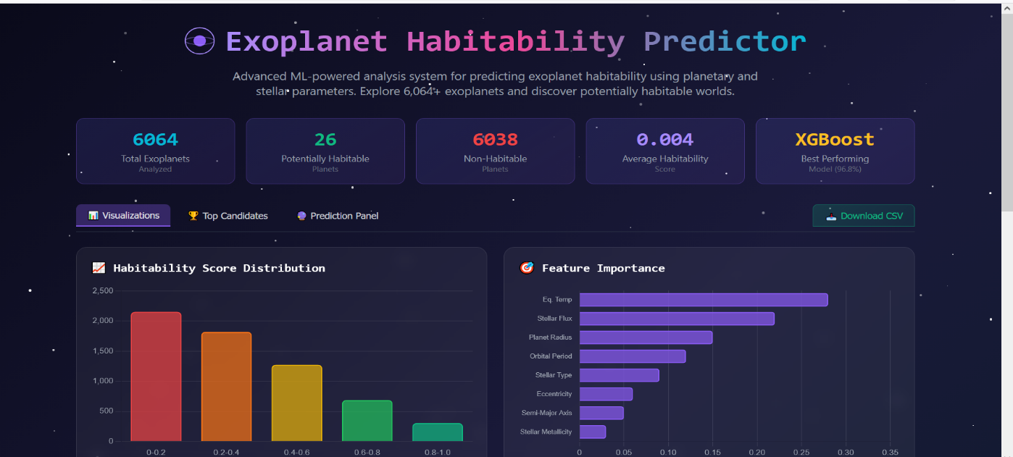

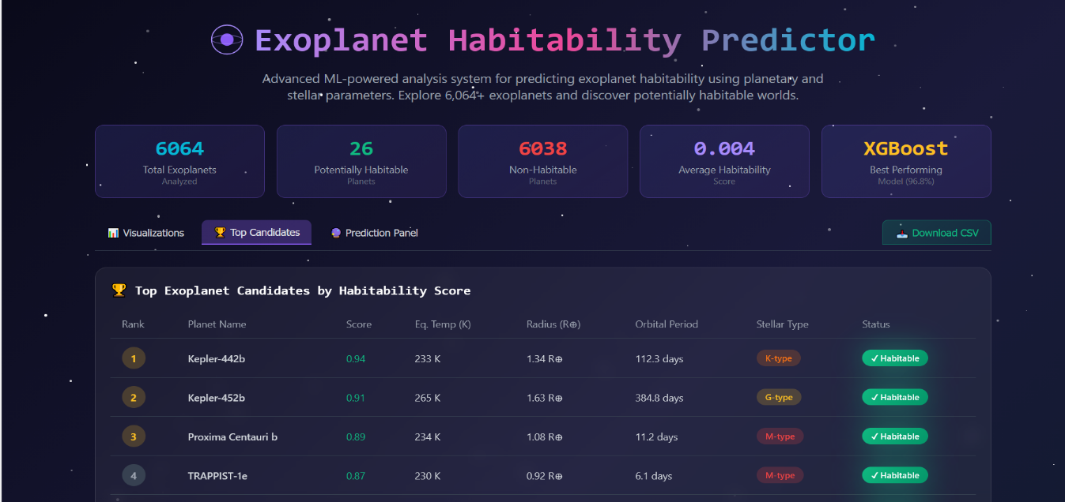
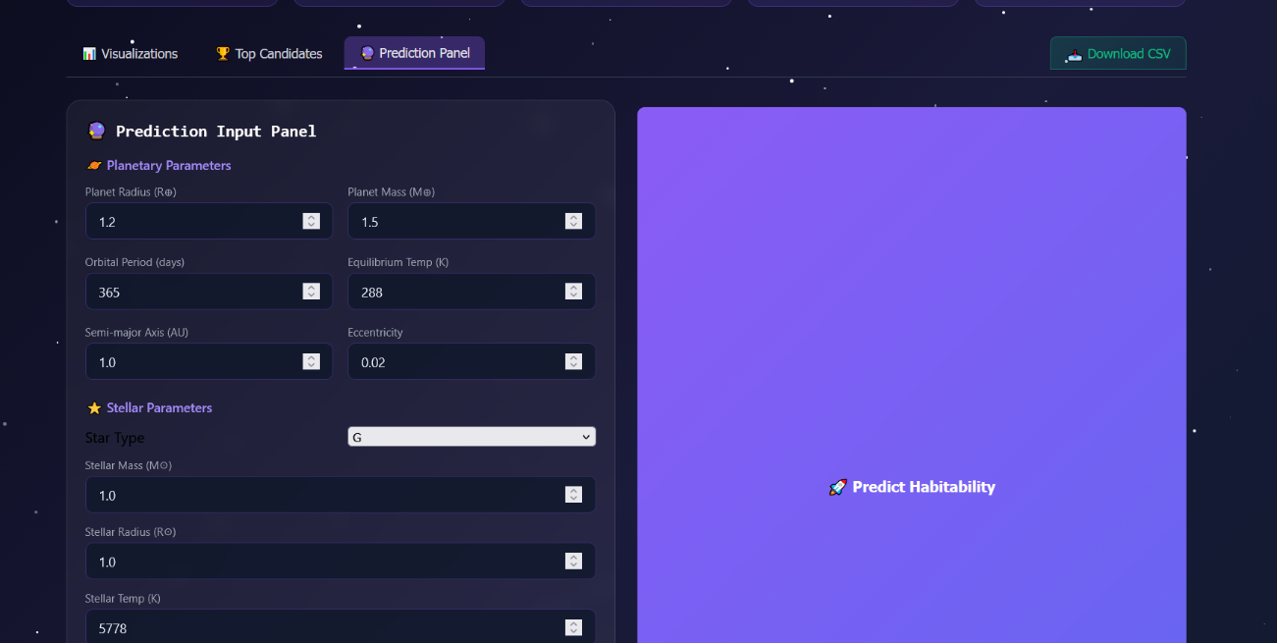

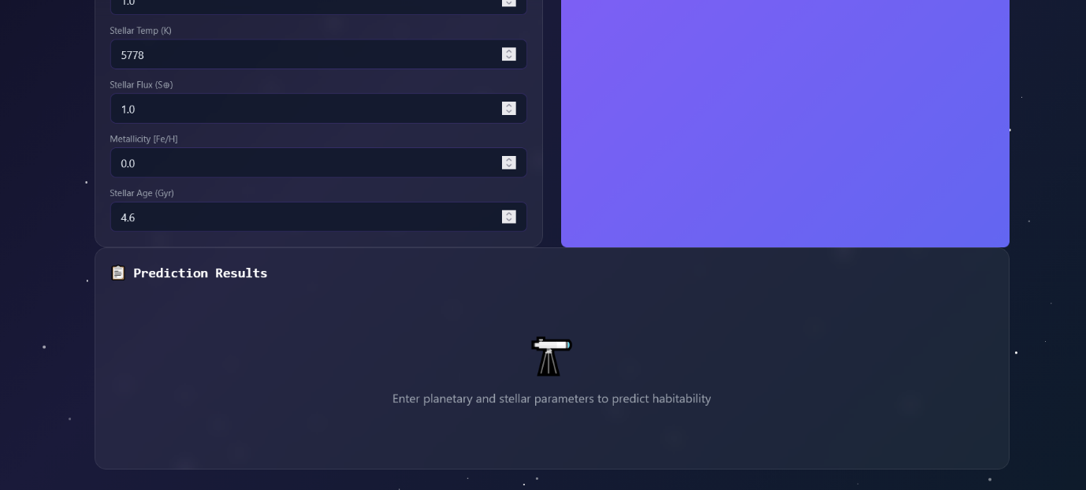

8. Conclusion
The ExoHabitAI Backend and Brontend successfully provides an intuitive, informative, and interactive interface for exoplanet habitability analysis.
It enhances the usability of the machine learning model and enables users to understand both predictions and underlying data patterns effectively.

